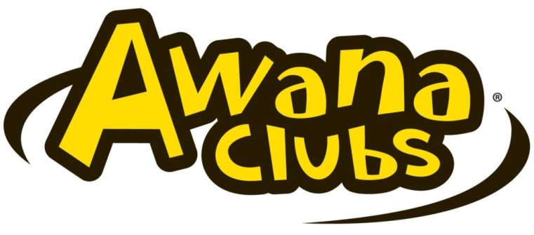
AWANA Schedule 2021/2022
September 12– Opening Club Night
September 19– Missionary Night
September 26 –
October 3– AWANA Kick-Off- Let your light shine
October 10–
October 17–
October 24 – NO AWANA | Fall Missions Conference
October 31 – Dress Up As your Favorite Bible Character
November 7 –
November 14 Bring A Friend Night
November 21 – Thanksgiving Celebration | No Gym Time- Craft Time
November 28 – No AWANA | Thanksgiving Break
December 5 – Crazy Hair Night
December 12 –
December 19 – Christmas Celebration | No Gym Time- Craft Time
December 26 – No AWANA | Christmas Break
January 2 – No AWANA | Christmas Break
January 9 –
January 16 – Popcorn night
January 23 –
January 30 – Pajama Night | No Gym Time- Craft Time
February 6 –
February 13 – Jersey Night- wear your favorite team jersey
February 20 – No AWANA | Winter Break
February 27-
March 6 – Grand Prix
March 13 –
March 20 – Hat Night
March 27–
April 3 –
April 10 – Resurrection Related Theme | NO Gym Time- Craft Time
April 17 – No AWANA | Resurrection Sunday
April 24 –
May 1 – Clashy Night
May 8 – No AWANA | Mother’s Day
May 15-
May 22– Closing Ceremony (during the evening service)

Service Opportunities*:
HELPERS in ALL AREAS

Theme Nights*:
Missionary Night- meet one of our missionaries
AWANA Kick-Off Night – “Let Your Light Shine” – Warm yourselves by the fire, roast hot dogs, and make s’mores as we remember to let our light shine for Jesus
Dress up as your favorite bible character Night – Come in your favorite costume. Let your imagination go wild and become a bible character-
Bring A Friend Night-
Crazy Hair Night – Any crazy style is welcomed here. Even washable hair spray paint can be a nice added touch.
Christmas Celebration- Do a craft for Christmas
Pajama Night – Wear your comfy PJs. Bring slippers if you want to feel extra cozy.
Jersey Night – Support your favorite sports team by wearing their shirt or jersey
Hat Night – Wear your favorite hat to club.
Clashy Night – Make sure your clothes don’t match on this night – plaids with stripes are in.

*Themes are subject to change and more themes may be added throughout the year so stay tuned!

